**A CASE STUDY ON VACCINATION IN INDIA**

**(EXPLORATORY DATA ANALYSIS USING R)**

**NAME - UDVAS DAS & NILABJA GHOSH**

**RAMKRISHNA MISSION VIVEKANANDA EDUCATIONAL AND RESEARCH INSTITUTE**



**DECLARATION**

“We affirm that we have identified all our sources and that no part of our project work uses unacknowledged materials.”

Signed,

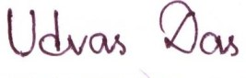

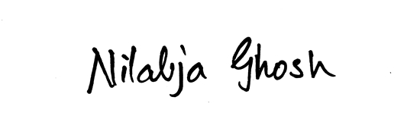

**INTRODUCTION**

On 11th March 2020 the World Health Organization (WHO) characterized the outbreak of the SAARS virus named Covid-19 as a global pandemic. In the past two years, the entire human race has experienced the most horrific time in the past century. A lot of things have changed since then including our lifestyles, necessities, day-to-day living etc. Our physical health, especially our mental health got affected heavily.

Many interesting projects in Biology, Statistics, Environmental sciences have come to light since the outbreak of the deadly disease. There is a lot of data which has been collected for these projects.

India reported it’s first covid case on 30th January, 2020 and after August the real havoc started. India became the state with second highest case numbers. After a year of immense struggle and hardship India started to vaccinate its citizens.

A lot of people in India were sceptical about vaccine because of the fake news circulated on social media and digital media in general. Vaccination in India progressed very slowly and took huge time to even vaccinate the elderly population. There are many reasons behind it apart from peoples’ perspectives. Nearly after a year or so it became possible to start vaccination for young people who are below 18 years age. Most of the young population is still not vaccinated, even with the first dose!

We have taken up this study titled “A case-study on vaccination in India” because we wanted to visualize people’s reliability on the vaccines provided in this country by different companies, the different parameters in the vaccination process with respect to the resident area types of residents etc. We were also interested to see if there is any patterns for different age groups towards the prejudices.

We will dive deep into visualization as we proceed in this project and draw meaningful inferences on the vaccination in India. The study will involve different parameters which are interlinked and the results will be multi-dimensional.